Assignment 13.1

Task-1:

Prompt:Give code for this code more efficient Code

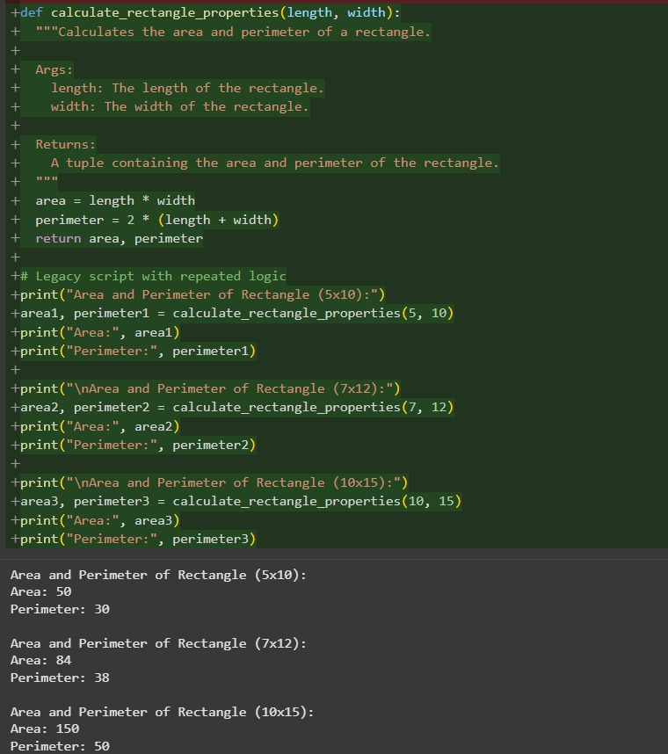Code and Output:

Observation: we can see that the Code is Optimized by the AI

Task-2:

Prompt: Improvise the given code

Code and Output:

Given Code:

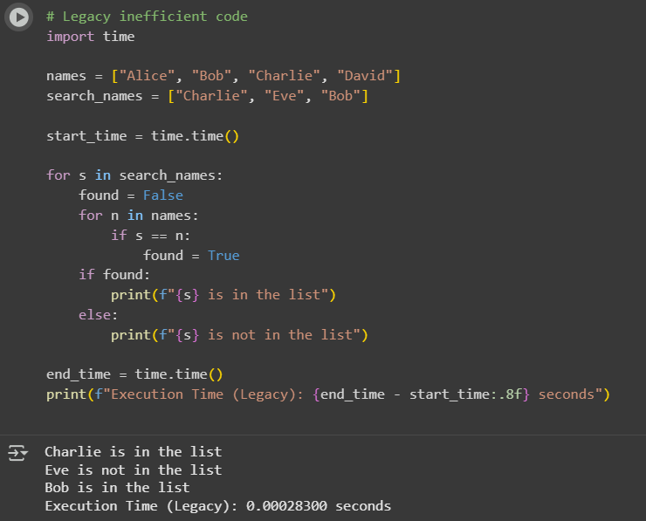

Improvised code:

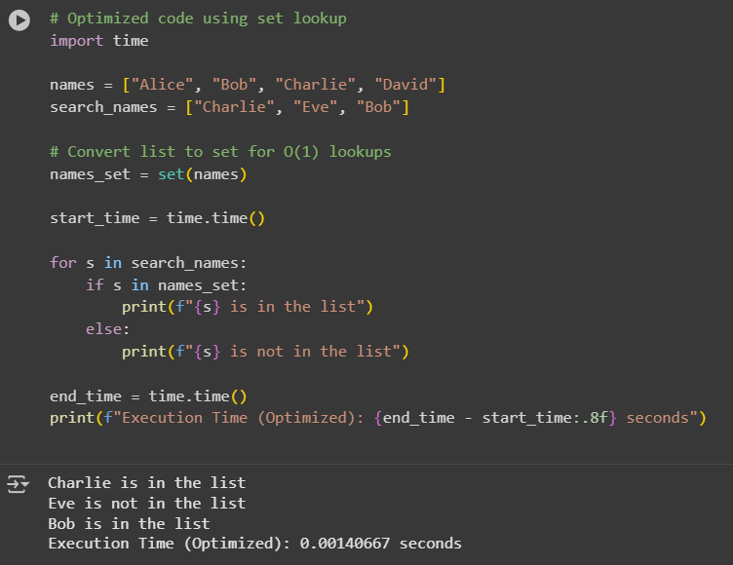

Observation: We can Observe That the code is improvised by the AI

Task-3:

Prompt:Refactor the given Code

Code and Output:

Before Refactoring:

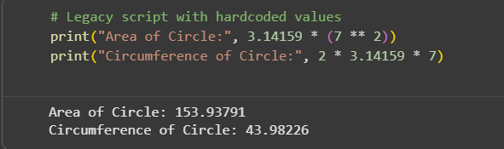

After Refactoring:

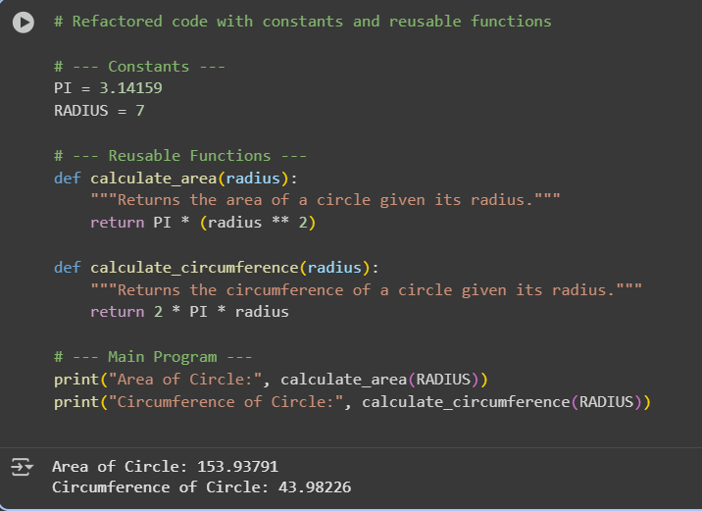

Observation:

In this question we can Observe that the Code is Refactored by the AI